**1.1 The problem domain**:

In contemporary marketing teams within companies, there is often difficulty in targeting the right clients for a product and determining which actions will attract or repel the ideal customer. While a trial-and-error approach works for some companies on a certain scale, effective targeting requires analytical tools that support informed marketing and development decisions. These decisions, in turn, drive company growth and increase revenue.

There are three main challenges in marketing intelligence analysis:

1. **Information gathering:**

The first challenge is identifying reliable sources for marketing intelligence, distinguishing important data from redundant information, and categorizing it effectively—tasks that are not easy to accomplish. Making informed marketing decisions requires massive amounts of data, but obtaining and organizing this data is complex. Common sources include social media, market trend analyses, and analyses of active user behavior, among others. Finally, organizing this data in a concise and analyzable manner presents another challenge, as it's impossible to consider all collected data in every marketing decision.

1. **Make correct analysis of the data:**

Once data is collected, using it wisely to make predictions is essential but challenging. Assessing whether these predictions have been “optimal” (i.e., the most productive) can sometimes be an unanswerable question. Additionally, deriving the correct conclusions from the data is not a trivial task.

1. **Presenting the information in a coherent and understandable way**

Converting large datasets into a human-readable format can be challenging and highly subjective; what may be clear to one person could be incomprehensible to another.

The goal of our project is to provide marketing professionals with a framework that automates parts of the analysis process. This includes auto-collection of relevant information from various sources, automated analysis of this data, and presenting the analysis results in a readable and understandable way. Of course, some of the challenges mentioned above will shift from problems faced by the marketing professional to problems we, as the developers of the product, will need to solve.

**1.2 Context:**

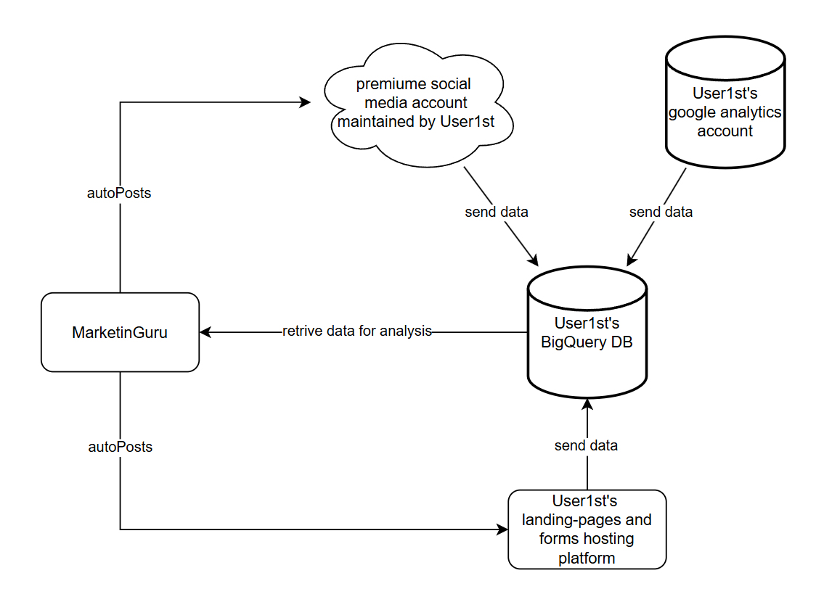

* **BigQuary**: is a Google product to which User1st subscribes. It is a data warehouse that provides fast querying capabilities and a platform for data analytics. User1st sends a large amount of relevant information from various components (described in the diagram) to this database. Our system will integrate with BigQuery to retrieve the data necessary for our operations.
* **Google analytics**: User1st also subscribes to Google Analytics, another Google product. This service provides insights into traffic analysis, audience demographics, acquisition tracking, behavior analysis, and more. Information from Google Analytics is sent to BigQuery, which our system then retrieves.
* **Landing pages and forms**: User1st maintains landing pages and forms for user acquisition and registration. Information from these pages is also sent to BigQuery for later retrieval. Our system will allow new landing pages to be posted with customized design and text at the click of a button.
* **Social media accounts**: User1st manages several social media accounts. Data gathered from these accounts—such as campaign success, liked posts, and demographics of primary visitors—is also sent to BigQuery for later use. Our system will communicate with these accounts, enabling posts to be made across multiple social media platforms simultaneously to ease the workload for the marketing team and maintain consistency across accounts.

**1.3 Vision:**

The main goal of our project is to provide a marketing analysis framework for the User1st marketing team that is personally tailored to their needs. Success will be achieved if our platform identifies the ideal customer profile (ICP) for User1st and simplifies the day-to-day work of marketing personnel.

**The tool will offer several key functionalities, including:**

* **Automatic Data Collection**: Gather data from multiple sources, such as social media campaigns, frequently searched keywords on search engines, and demographics of active and potential users.
* **Automated Data Analysis**: Analyze the collected data to identify the ICP and detect trends in the dynamic market.
* **Customizable Data Presentation**: Display data in customizable charts and diagrams for the convenience of the marketing team.
* **Landing Page Auto-Posting**: Provide an interface to automatically create and post customizable landing pages to increase User1st’s digital footprint, thereby enhancing data collection.
* **Automated Social Media Posting**: Enable automatic posting on multiple social media platforms simultaneously, further augmenting the data collected.

The main challenges we will address include integrating with User1st's existing data collection methods (such as Google Analytics, premium social media accounts, User1st landing pages, and forms) and enhancing these sources. We will also focus on filtering essential information from irrelevant data, developing a suitable dashboard for the marketing team, and integrating with User1st’s social accounts and landing page hosting to enable automation tools.

**Once the core system is implemented and major obstacles are addressed, we envision expanding the system as follows:**

* **Social Media Crawlers**: Develop crawlers to scan social media platforms, identifying potential influencers for User1st campaigns and potential clients.
* **AI-Powered Market Prediction**: Utilize state-of-the-art AI techniques to forecast market shifts and evolving ICPs.
* **ROI Analysis**: Analyze campaign return on investment (ROI) to detect when a campaign has reached the point of diminishing returns.
* **User Action Analysis**: Examine actions taken by users on the User1st site, identifying behaviors that may deter purchases.
* **Cookie-Based Behavior Analysis**: Use cookies to analyze user behavior and facilitate targeted advertising.

**1.4 Stakeholders:**

* **User1st’s Marketing Team (Informed Customers):**

The marketing team will be the primary user of our system. Requirements are primarily elicited from them, and they provide feedback on whether a feature is redundant, important, or highly useful.

* **User1st’s R&D Team (Technology Experts):**

User1st's research and development team will help us determine which customer-suggested requirements are feasible given the company’s resources, which would be too costly to maintain, and what can be achieved within the project's timeframe. The R&D team will also assist us in seamlessly integrating our system with the company’s existing infrastructure.

* **User1st’s Legal Department (Law Experts):**

The legal department will help us ensure that proposed features and requirements are lawful and will provide guidance on adjustments if any elements are non-compliant.

**1.5 Software context:**

**Input:**

As mentioned, the primary input for our system is user data collected from various sources. The following list provides a guideline for the types of data our platform will gather:

* From google analytics:
* **Age, Gender, Location**: can help with understanding the ICP
* **Device and Browser Type**: devices type (mobile, desktop) and browsers (Chrome, Safari, etc.) that users prefer helps in optimizing website design and functionality.
* **Referral Sources**: where users come from (direct, search engines, social media, other websites). can help in understanding which channels drive the most traffic.
* **Page Views and Session Duration**: helping assess content effectiveness.
* **Bounce Rate**: Indicates if users leave immediately after visiting a page, which can reveal issues with relevance and user experience.
* **Conversion Rate**: Measures the percentage of users who complete specific goals, such as signing up, purchasing, or subscribing.
* **Click Path Analysis**: Tracks the sequence of pages visited by users, helping identify common paths or drop-off points.
* **Frequency and Recency**: Shows how often and how recently users return, helping gauge brand loyalty.
* **Interest Categories**: Using Google’s affinity data, marketers can understand users' broader interests (e.g., travel, fitness), which helps in targeted ad placements and content strategy.
* From social media:
* **Demographics**: understanding the potential user age, gender, location, job titles, income, education level, behaviours, interests, and values. This helps in refining the ICP.
* **Likes, Comments, Shares, and Reactions**: helps in understanding the ICP and the effectiveness of a campaign
* **Click-Through Rate**: The percentage of people who click on your ad or post out of the total number who saw it. Can gauge campaign effectiveness
* **Ad Placement Insights**: how ads performed across different placements (e.g., feed, stories, sidebar), helping optimize campaign decisions.
* **Behavioral Data**: Insights into how users interact with your content (e.g., time spent, clicks, engagement with specific parts of your post or video) help optimize future campaigns.
* From landing pages and forms (ask what data can be collected?):

Another form of input is the auto-posting tool which is pretty straight forward:

* Auto-posting on social media: takes text of the post, an optional image, and a list of social networks to which we want to post.
* Auto-posting landing pages: takes the customizable element of a landing page (text, color, logo, images and so on) and generate a new landing page with those properties.

**Processing:**

The primary processing function of the software involves making predictions based on collected data through machine learning and statistical analysis. Examples of potential conclusions include identifying the ICP, determining which campaigns are successful, discovering keywords that attract the target audience, and identifying locations where campaigns succeed or fail.

The AI models to be used are yet to be determined.

**Output:**

There are four main output channels:

* **Dashboard Display**: Collected data is presented in the software UI (dashboard) in a customizable way, allowing each user to select specific charts and query the system accordingly.
* **Marketing Suggestions**: Based on collected data, the system provides a set of predefined recommendations regarding the target audience, campaign success, and more.
* **Social Media Posts**: Posts generated by the auto-posting mechanism.
* **Landing Pages**: Generated by the auto-posting landing page mechanism.